Sawnee-Cumming Optimist Club

P.O Box 945
Cumming, Georgia 30028
Georgia District * Zone 4

Contact Larry Brown 404-538-1631
Browntrust@bellsouth.net

Optimists Honor Deputy First Class Loucks

CUMMING, GA, August 8, 2022 - The Sawnee-Cumming Optimist Club recognized Forsyth County Sheriff’s Deputy First Class De’Andre Loucks at the club’s 2022 Respect for Law program. At a club meeting, Deputy Loucks was presented a plaque with the inscription “For your outstanding contributions to the youth of Forsyth County.”

“Among a variety of programs to bring out the best in youth and communities, honoring law enforcement officials is one of the tenants of the Optimist Club,” explained club president Carolynn Martin. “Our goal is to inspire respect for law enforcement among young people and to educate them on the vital jobs of law enforcement men and women.”

“It is a pleasure to see Deputy Loucks receive the Sawnee-Cumming Optimist Club award,” commented Sheriff Ron Freeman. “To be recognized by such a prestigious organization is a testament to Deputy Loucks’ professionalism and bravery. On behalf of all the men and women of the Forsyth County Sheriff’s Office we are grateful to the Sawnee-Cumming Optimist Club.”

"This award is a small token representing the collective enthusiasm and gratitude we have for the self-sacrifice and desire Deputy Loucks has shown to make Forsyth County an ideal place to live and work,” remarked the club’s Respect for Law committee chairperson Robyn Ulatowski. “We are proud to honor Deputy Loucks, representing everyone in Sheriff Freeman’s department.”

Photos:

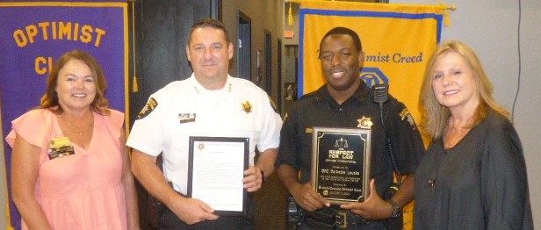
Deputy First Class De’Andre Loucks (second from right) was presented a Sawnee-Cumming Optimist Club appreciation plaque by Respect for Law Committee chairperson Robin Ulatowski (right) and club president Carolynn Martin, with Sheriff Ron Freeman.

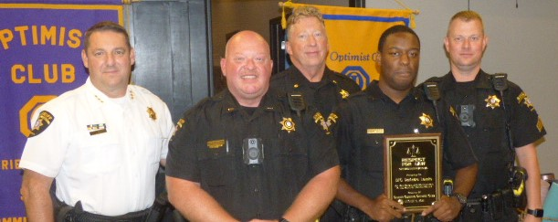
Officers attending the Optimist Club award presentation (from left): Sheriff Freeman, Lieutenant Scotty Spriggs, Deputy First Class Loucks, and Sergeant Bobby Francis.

